**Project Development Phase**

| **Date** | **11 November 2022** |
| --- | --- |
| **Team Id** | **PNT2022TMID16827** |
| **Project name** | **Project - Visualising and Predicting Heart diseases with an interactive dashboard** |

**Sprint-2**

**Profile-** To Know the User about Him/Her Information and provide to Generate the Report for his Analysis

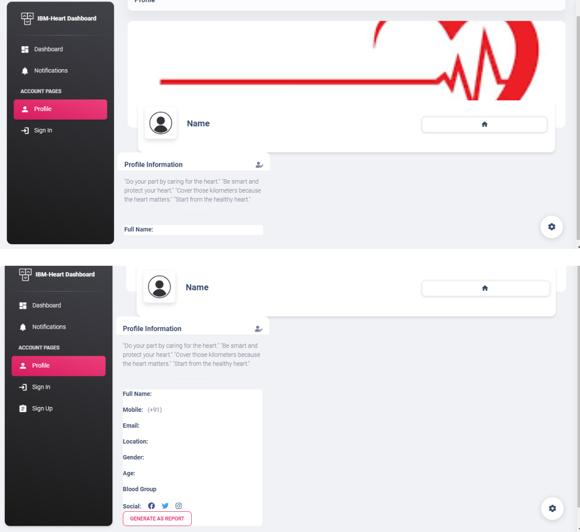

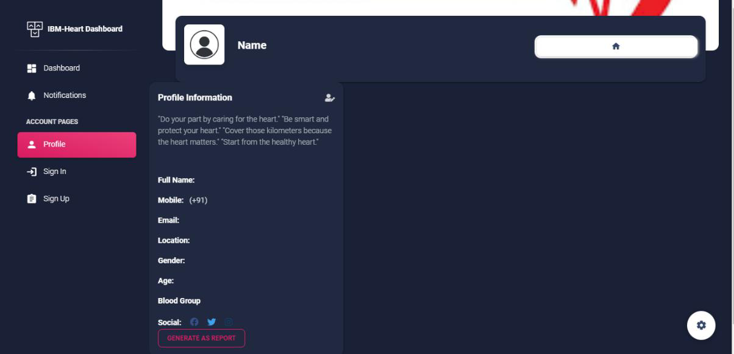

**Dataset collection -** The data required for analysis and prediction must be collected from various sources,Collecting Dataset from Different Site.

